Mmabatho/Deddington
The Parish Church of St Peter and St Paul, Deddington is linked with the Church of the Resurrection in Mafikeng/ Mmabatho in South Africa’s North West Province. The link is centred on the work of the Resurrection to combat HIV/AIDS. Deddington helped bring into being within the grounds of the Resurrection the Tsogo (Resurrection) Centre which provides care for pre-school children infected or affected by HIV/AIDS.
Several Deddington parishioners have travelled to Mafikeng / Mmabatho, a particularly memorable visit being that to the Kimberlely and Kuruman Diocese’s Family Weekend in 2005. A group from the Church of the Resurrection visited Deddington in 2007, and in May 2010, the Resurrection’s Choir took part in the Maurice Frost Festival in Deddington, a highlight of which was a Eucharist also involving a choir from Deddington’s link parish in the Diocese of Växjö. The service, possibly uniquely, combined the Setswana, Swedish and English languages.

Mothibistad/Icknield
For several years Icknield Benefice has enjoyed an active link with St Paul’s, an Anglican church in the black township of Mothibistad, in South Africa’s Northern Cape Province. We’ve been inspired by the energy of their worship and their determination to put Christ’s gospel of hope into practical action for the most vulnerable in their community. Warm friendships have developed between the two congregations. 11 of us have been welcomed to Mothibistad, and 16 people from the township have stayed with us in Oxfordshire. We’ve learned so much from each other, both about our shared faith and our approach to common challenges like schooling, health, and care for the elderly.
Mothibistad is in a mainly rural area with very high levels of unemployment and poverty. Over recent years HIV/Aids has devastated hundreds of families there. The Church has a vital role supporting people with the disease, and seeking to strengthen communities threatened by its impact. The congregations of the Icknield benefice are helping to fund community projects to provide “unconditional love, care and support” for local people infected by HIV/Aids in and around the township. One such project is the food-parcel service ‘Valley of Hope’.
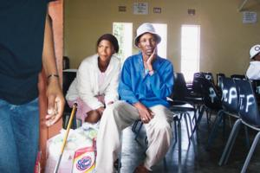
The photograph shows members of a needy family waiting to be taken home with their monthly grocery parcel. The VOH team in Mothibistad collect them, bring them in to St.Pauls to collect the parcel; give them lunch then take them back to their village. Over time they are now starting to get to know other people from other villages, as well as us. This is also a way of making sure the family gets the groceries meant for them.
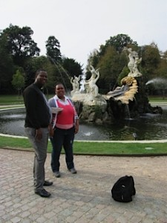
History
The Icknield Benefice is Linked with the Parish of Mothibistad, on the edge of the Kalahari in the Northern Province of South Africa. It was started in 1995 by Canon Tony Williamson as part of a wider relationship between the Oxford Diocese and the Diocese of Kimberley & Kuruman.
Canon Tony Williamson spent the formative years in forging relationships with the clergy. He visited them and they visited Watlington and in 2003 as the Link strengthened he asked three members of St.Leonard’s congregation to accompany him. A lot of the visit was spent in visiting the township schools and getting to know the teachers .
2006 at the height of the HIV/AIDS Pandemic saw the introduction of Pauline Verbe and Dorothy Ackerman who subsequently became very much involved in providing Grocery Parcels for the victims of HIV/AIDS, their orphans and their Carers. They concentrated in ways of getting the community to start helping themselves. Since that time we now see them making their own clothes, getting involved in sport and music and most recently in starting to grow their own vegetables and fruit.
During this time Revd Christopher Evans began visiting and spent much of his time in the rural villages ministering to the sick and dying, often accompanied by David Blake, who has come to be known as ‘Our Man in South Africa’ – due to the fact he lives in Capetown and is a great help to our Link.
2010 – saw the formation of the Icknield Benefice Churches own Charity – The Valley of Hope (UK) Charity whose current project is the raising of funds to provide for Grocery Parcels.
2012 – this is the year when we very much hope to progress further by seeing new people becoming involved and hope they will bring new projects and people to strengthen the Link Further

Galeshewe/Marlow
Welcome to the page for the link between the Marlow Team and St James, Galeshewe. Read a short history of the Marlow – Galeshewe link… or catch up with the latest news below.

Latest News

Visit of Archdeacon Reggie Leeuw
For the two last weeks of September Father Reggie Leeuw, the priest from our link church of Saint James in Galeshewe, a township of Kimberley, South Africa, together with his wife Noma were with us here in Marlow. It was a delight to have them and to include them in activities across the parish. Although Father Reggie had been over here before and had attended a course at Cuddesdon Theological College, Oxford, Noma had never been out of their country before, so everything was very new for her. Father Reggie is also Archdeacon of the Karoo, a vast arid area south west of Kimberley and his responsibilities there involve traveling very long distances.
The day after their arrival they were invited to a “meet the parish” bring and share supper in the Church Hall. There was good representation from all the four Team Churches and Reggie and Noma soon showed how easy they are at mixing and relating to others. Right from the start they demonstrated their interest and friendship and were excellent ambassadors. 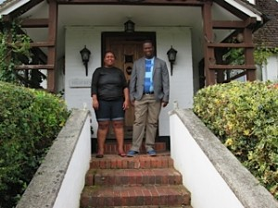Their activities were many and varied and they participated in everything with great enthusiasm.
There was a guided tour of All Saints Bisham, a day out in London including a river trip and the poppies at the Tower, Cliveden, Wycombe on market day and meals with different members of clergy and congregations. Father Reggie preached at 9.15 and 10.59 at All Saints Marlow, at 9.30 at Bisham and they attended the 4.30 Family Service at Saint John the Baptist, Little Marlow. He also spoke at morning assemblies at both Sandygate and Holy Trinity and enjoyed a House Group Meeting, Bisham Harvest Supper and was interviewed on Marlow FM.
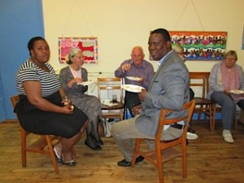
A highlight of their visit was being able to join those attending The Grand Day Out centred on Christchurch Meadows, Oxford a lovely Diocesan get together celebrating John Pritchard’s time with us as Bishop of Oxford. Reggie participated in a question and answer session there with Bishop Andrew of Reading. It was also lovely to meet up with Bishop Ossie, Bishop of Kimberley and Kuruman and in his Archdeacon capacity it was good that Father Reggie was able to have several meetings with Bishop Ossie, Bishop Andrew and the Archdeacon of Berkshire enabling them to discuss the Diocesan Link with South Africa. They were also able to join in the Pilgrimage Walk with Bishop John on the stretch from Marlow to Maidenhead which was a very moving experience for them. On their final evening Saint Mary’s Marlow Bottom hosted a lovely farewell party for them with a special cake. They really appreciated the occasion which rounded off their activities around the parish beautifully. They have returned to Saint James with warm wishes of friendship and the hope of opportunities to build on our relationships. It highlighted the way that we have the same hopes, problems, joys and above all, faith. On their return they were excited to see their two small sons, Phemelo and Tumelo and one exhausted Grandma!

A Visit for the 50th Anniversary of St James, Galeshewe
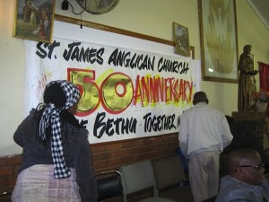
Sonke Bethu – together in Christ. This was the the message from Saint James during the year of celebration for 50 years since the church opened on their patronal festival 1962. James Valentine and I were delighted to be with them for this very special occasion.
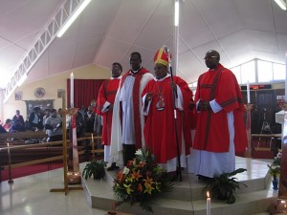
Father Wade, vicar of one of the other churches, saw a need for a church there over 50 years ago. It was his vision that resulted in a metal frame being designed and erected and the local people then took ownership and did the brick building within the framework themselves. The result is a lovely church with a central marble altarpiece. The banner which Helen Munday in Marlow made showing the four Marlow Team Churches has pride of place and looks great. The service on Wednesday evening, the patronal festival, was attended by about 50 clergy including Bishop Ossie Swartz bishop of Kimberley and also the suffragan bishop Patrick Matolengwe. There was a large congregation and much lovely singing, often old English hymnal hymns but sung with an extraordinary African slant, much harmony, rhythm and movement and in Setswana. All the services we went to were Eucharistic. It was very moving. Afterwards everyone gathered in the church hall for rooibos tea and cake and chattering and it was wonderful to meet old friends. We were made effusively welcome.

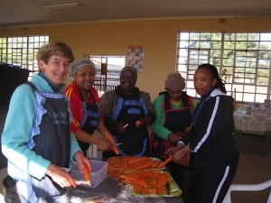
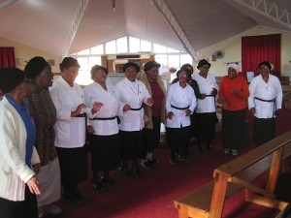On Thursday afternoon I went to Saint James for the MU meeting where I was able to give Nomi Tau, their chairman, news from Mary Baker as representative from Marlow. They are a very vibrant group all appearing in their uniform for meetings and many wearing it every Sunday for services – black skirt, white blouse, black sash and black beret.They are very smart and very proud of their group appearance. They were practising songs and dancing for the big celebration service on Sunday. Whilst I had been involved with this James had been experiencing something which I was very glad to have missed! Two cows and a number of sheep were slaughtered in the churchyard ready for the feast. They had also initiated the beer brewing process!
After breakfast on Friday it was off to Saint James for hard work. We prepared food for 500 for the Gala evening. This was held in the community centre next to the church and it had been beautifully hung with drapes etc. by a team run by a member of the congregation who organises it for weddings etc. It was quite a sight and although there were many there who were beautifully dressed in sophisticated clothing there were also many still in jumpers and woollie hats – a real gathering for everyone.
The evening was opened with a speech by the Lady Mayor, and various dignitaries. We were able to send our greetings from Marlow. Then the Youth Group excelled themselves delivering the meals which looked and tasted great. After that there was dancing. Saint James congregation certainly knows how to enjoy itself – a wonderful example of a warm, Christian community at play, celebrating the considerable achievement that the church there had made over the last 50 years during which there have certainly been downs as well as ups. We pray that the future will now continue with the devout and happy atmosphere that we were privileged to experience.
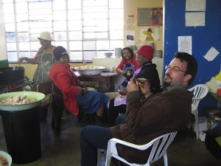
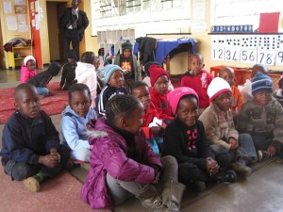
Saturday we were down at the church at 10.30 where we again prepared food for the Sunday celebrations. I was taken home at 10.30 pm but many were still working until the early hours of the morning. We were at Saint James at 8.30 for the service. Once gathered we processed around the township – about 1,000 people including our 2 white faces! The choir were all grouped together and there was great singing. What a demonstration of Christian commitment to Saint James’. The Service then proceeded and we had a sermon by Right Rev. Theophillus Naledi retired Bishop of Matebeleland, Zimbabwe who had been their first Rector. We felt so blessed to be there for this very special time. At lunchtime we progressed to Church Hall [as VIPs] whilst lunch for the majority was served in church. Their faith, church and church community form the central part of their lives and it is really heart warming to experience. We both felt very privileged to have contributed in a small way to this amazing event and we pray that Saint James’ grows and flourishes peacefully for the next 50 years. Over the rest of our stay we were able to visit the Cathedral, local schools, playgroups, the sights of Kimberley and experience life in this fascinating part of the world. We felt very blessed to have had this opportunity. Sue Glyn-Woods.

n 1994 Father James Keetile, parish priest of Saint James, Galashewe, a Kimberley township, stayed in Marlow whilst over here studying in Oxford. Following this visit a link was encouraged between the two parishes, supported by both bishops. In 1995 Nick and Beryl Molony visited Galeshewe in order to build up a relationship between the two parishes. Since then there have been visits from and to our link church by various people including Don Majosi, their undertaker and Gary Lester a teacher from Holy Trinity School.
In 1998 Colin Cockshaw of USPG flagged up Zenzelini – a project to support HIV/Aids orphans. The then incumbent, Father Ben Ngoako at Saint James identified this as their priority for the next 5 years. In 1999 Mieke Gaynor from Marlow visited with a view to promoting this project and to this end she spent 3 months there in 2001. Although much admirable work was achieved there were problems with the organisation of this work and Zenzelini is now being run by the Social Services and continues to provide a valuable service.
Saint James Choir during this period was gaining renown, winning many awards and competitions. It was suggested that it might be possible for them to visit Marlow, introduce their link parish to their amazing music, be ambassadors for the Northern Cape and perform for the assembled bishops at Wycombe Abbey when they gathered prior to the Diocesan Conference at Wycombe Abbey. This they did with considerable success. 23 members found their own fares [with the help of sponsorship from de Beers] and were then given hospitality with families across the parish on a bed and breakfast basis. A Team Group met each morning to prepare packed lunches for them and a rota of Team groups prepared their evening meals in the Church Hall. Marlow certainly enjoyed much African music in the churches, in the schools, on buses, in the streets – everywhere including a recital at the conference in Wycombe, in All Saints’ Marlow, Christchurch Cathedral, Oxford and Saint Paul’s Cathedral. It was a tremendous experience and many lasting friendships were made.
Saint James went through a difficult period and in 2004 Father Ben left the parish. At this time and during the interregnum there were no visits in either direction. With the arrival of Bishop Ossie Swartz as Bishop of Kimberley and Kuruman the situation improved and in November 2007 Sue Glyn-Woods and Rosemary Lewis were able to visit to re-establish communications and gather information.
By this time Saint James was again a vibrant, devout, active and inspiring church which is hugely involved in the local community. Galeshewe, the black township for Kimberley has about 70,000 inhabitants some of whom are reasonably comfortably off and well housed but many of whom are living in shacks. Congregation members have good understanding and compassion for their members. There is a very active and flourishing pre-school and we visited this which is in the Saint James complex and supervised by their Vestry Committee [PCC]. They had 58 children but this was because numbers drop before Christmas and it is usually 63. The children pay 60 rands a month plus 10 rands contribution to funds. This money covers their care 7am – 3.30pm. They get breakfast on arrival – different varieties of miele or oat porridge with milk and sugar, later on a snack of bread and jam or peanut butter and then a main course with vegetables for lunch, followed by fruit. For many this is all the food they get. Child allowance more than covers this expenditure. The exchange rate varies but when we went was 15 rand to £. The preschool were 5-6 year olds and do basic lessons. We saw the work they had done with colouring, numbers, counting, writing their names and letters. It was quite impressive. On Dec 2nd they were due to have their “graduation” as some would be going on to big school after their summer holidays and two delightful little tots put on their graduation robes for our photo call. The head teacher, Susan, had 2 young assistants and there are usually 3 but one had a sick child. They all sang a series of action Christian choruses for us – quite enchanting. One sad aspect was the fact that they had no equipment to play with out of doors and the sizeable outdoor space is just an earth area with some car tyres and a small ramshackle slide which Health and safety here would condemn.
On our return we were able to hand over £500 which our Saint James group had raised to Bishop Ossie who then handed it over to a lady from Oxford who was working in Kimberley and together with members of their PCC they chose suitable play equipment and we were sent all the bills showing what had been purchased.
Saint James’ had been without a stipendiary priest for several years but in 2010 Father Reggie Leeuw took up the post and he and his wife and young family moved into the Rectory. They have settled in well and are proving extremely popular in this large parish. There is currently much excitement as 25th July 2012, their patronal festival, will mark 50years of the church and there are many plans afoot to celebrate this occasion.
If we are to continue our association with Saint James’ we shall need commitment from both sides. Marlow Team has embarked on a new Youth Project and Saint James also has a new Youth Club “which is being supported 100% with a very positive response from the youth side.” This might be a field in which we could support each other – there are aspects here that could form an exciting basis for the next 5 years. We have contacted Saint James to get their views on this, to assess their commitment for building for our joint futures, to hear their plans and assess what involvement could be beneficial. We would need a five year plan and enthusiasm from both sides. We feel there is scope for an exciting project with mutual benefits.

