If you’ve enjoyed your visit and have 5 minutes to spare here’s a list of routine tasks which can be carried out by anyone who’s willing:
Micro Volunteering

- Sweep leaves and dirt from the church
- Polish wooden surfaces with a soft cloth
- Pull any large weeds from around the perimeter base of the building
- Sweep or tidy the path to the gate
- Tidy the visitor table and dust / clean the display stand if necessary
- Have a walk around the church, note any suggestions for improvement and send them to west@thecct.org.uk

Why not take a photo of yourself doing any of the above and post on social media? Don’t forget to tag us.
Facebook: @ChurchesConservationTrust
X: @theCCT
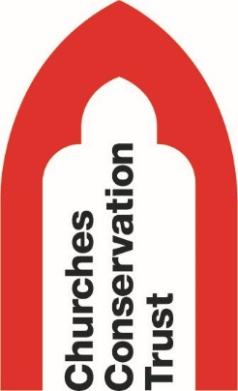
Instagram: @churchesconservationtrust

Thanks for your time and don’t forget to sign the visitor book
www.visitchurches.org.uk

