St Mary’s, North Leigh Churchyard Summer Plant Treasure Hunt – August 2023
See how many of the plants below you can find – they are all in the churchyard so don’t go out of any of the gates! Record where you find each plant on the plan and if you know the name write it on this sheet. Try not to trample on other flowers or creatures as you hunt. Happy hunting!
 | What I look like | Clue | Describe me and where I like to live – e.g. am I a tree a bush or low to the ground – do I like the sun or shade. Do you know my name?
1 | 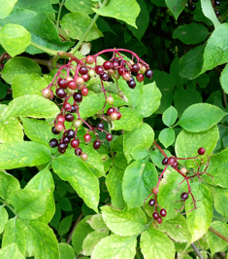 | My berries are turning dark purple and some people like making wine from them. My flowers can also be used for making cordial.
2 | 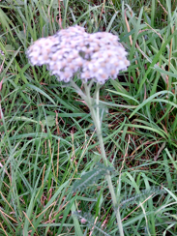 | I have pinky-white flowers – and usually you will see quite a few of me together. I also have delicate feathery leaves below my flowers.
3 | 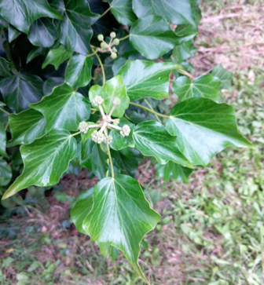 | Some people find me creepy and often only notice my evergreen leaves but as you can see, I also have flowers and berries at this time of the year

4 | 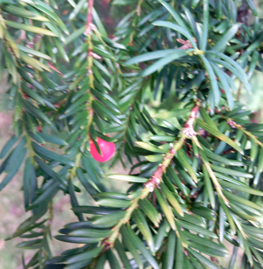 | I am very common in churchyards and have soft needles and red berries – don’t touch me as I am poisonous, particularly my red berries!
5 | 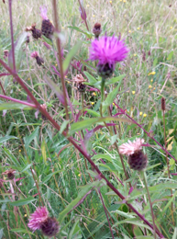 | My pinky-purple flowers are now fading but you can see my seed heads. If I am still in flower, on a sunny day you will see bees and butterflies around me.
6 | 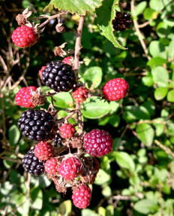 | I like having my fruits eaten by birds at this time of the year because it helps spread my seeds and grow new plants. People like eating me too! Mind my thorns though.
7 | 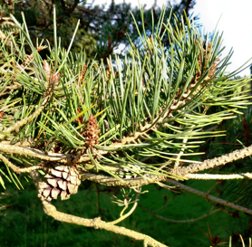 | You can’t use my needles for sewing nor my cones for ice cream.

8 | 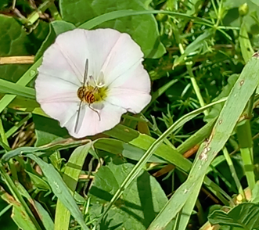 | You will see my pretty pink and white flowers facing upwards to the sun- also making a cup to hold water that some insects enjoy
9 | 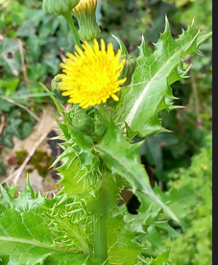 | Hopefully my lovely yellow flowers are still out, however you can also identify me by my prickly leaves. (My picture was taken close to the Church.)
10 | 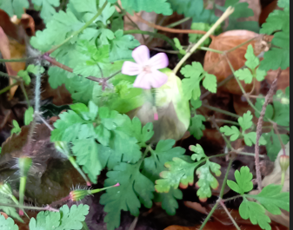 | You may see my pretty little flowers with five petals, but if not look out for my delicate leaves. Be careful you don’t tread on me though…
11 | 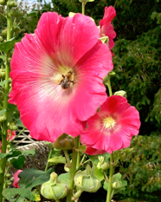 | You really can’t miss me – certainly the bees see me and are still enjoying visiting me.

12 | 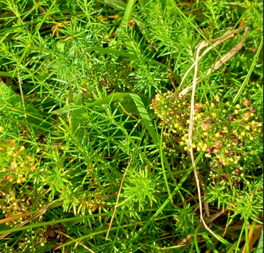 | My small frothy looking yellow flowers have mostly gone now but you can still see my fine soft leaves.
13 | 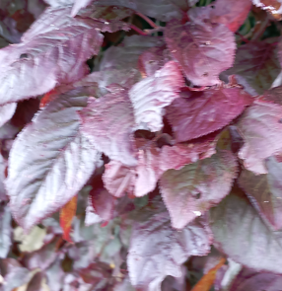 | My shiny purple leaves make me very different from anyone else in the churchyard – see if you can find me!
14 | 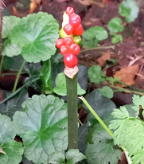 | I can be difficult to find, but once you know where I am, my red berries are very clear to see – but don’t touch as I am poisonous!
15 | 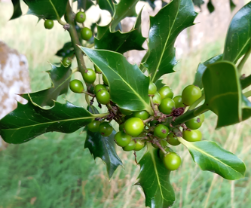 | My berries will turn red over the next few weeks – people often sing about me at Christmas along with my friend in number 3 above. Mind my prickly leaves!
16 | Finally, how many bird boxes can you see in the churchyard? Mark them on your plan with a letter ‘B’

